Please delete all the italic text before submission. It is here just for your reference.

Further: data set – DS, research question – RQ

The mark (x words) after each subchapter states the word count limit. This indicates the expected amount of information which you can exceed by 10% without losing the mark.

7COM1079-0901-2025 - Team Research and Development Project

Final report title: (the topic of your research.)

Group ID:

Dataset number:

Prepared by: [Name and ID of submitting student first],
[Name and ID of other group members]

Please make sure the document spelled correctly (including image labels, section headings, and table of contents). Please use correct punctuation.
Make sure your report is grammatically correct.

University of Hertfordshire
Hatfield, 2025

Table of Contents add page numbers from here

- Introduction
1.1. Problem statement and motivation for the research
What makes populations happier is an important and pervasive global issue due to human well-being as well as productivity and development generally. It is unclear though how closely economic conditions have an impact on national happiness. Even in the face of less economic output, some countries achieve high levels of happiness, while others fail to live well even when they are wealthier. This discrepancy creates the demand to better investigate the relationship between happiness and economic well-being. The paper examines whether GDP per Capita is meaningfully linked with higher Happiness Scores, in a study that utilises the World Happiness Report 2016 dataset, comparing 157 countries between them on a number of wellbeing variables (Helliwell, Layard, & Sachs, 2016).

1.2. The dataset
The dataset used in this study is the World Happiness Report 2016, with data from 157 countries. Each row is a country and measures a country’s happiness score, economic performance, social support, health, freedom, generosity, and perceptions of corruption. It provides numerical data, so countries can be compared and statistical analysis of global happiness patterns based on their statistics. In this study, the variables “Happiness Score” and “Economy (GDP per Capita)” were selected to examine the correlation between economic prosperity and national happiness level.

  - Research question

Is there a correlation between the happiness score of the country and GDP per capita in the 2016 World Happiness Report?
“This study examines a correlation between Happiness Score and Economy (GDP per Capita) for the 2016 World Happiness dataset among countries. The question we want to answer here is whether greater economic prosperity is associated with greater national happiness.”

H0/H1 = null hypothesis and alternative hypothesis
Pearson correlation to see if there is a statistical effect between Happiness Score and Economy (GDP per capita). The hypotheses are used to determine the expectations before running the analyses. The null hypothesis (H₀): No connection is found between happiness levels nationally and economic prosperity; any observed relationship is due to chance. In contrast, the alternative hypothesis (H₁) asserts a relationship between the two variables with an increase in a country’s economic output being directly related to an increase in its happiness score. These assumptions can help analyze the statistical testing and decide whether to test the relationship in a meaningful or not way.

2. Background research

2.1. Research papers (at least 3 related to the topic/DS for your research / DS).
• Becchetti, L., Corrado, L. & Sama, P. (2016) ‘Inside the Life-Satisfaction Blackbox’, World Happiness Report 2016, Chapter 2, pp. 89-120. The authors extract from the same dataset including the cross-national level of satisfaction and how different life-satisfaction instruments (e.g., social support, health, GDP per capita) relate to the overall happiness. They discover GDP per capita stays a strong predictor but is mediated by social and health-related changes. files.worldhappiness.report+1.
• Helliwell, J.F. (2016) ‘The Distribution of World Happiness’, World Happiness Report 2016, Chapter 2, pp. 23-54. Helliwell looks at a general pattern with the 2016 data collected and explains the vast disparities in happiness across countries by looking at economic output, healthy life expectancy and freedom to make choices. files.worldhappiness.report+1.
• Lee, Y.Y. (2023) ‘The Happiness-Economic Well-Being Nexus: New Insights’, SAGE Open, 13(2). This recent research extrapolates from worldwide happiness indicators and looks at how (and if) national economic policies matter for subjective happiness, finding a strong relationship between GDP per capita and happiness scores.

2.2. Reasons for RQ interest (research gap and what's next according to the literature). While earlier research indicates how economic wealth contributes to national wellbeing, previous research also shows that GDP does not account for how various countries differ in their happiness. Some countries have significant happiness even if they do little in economic output, other countries have lower happiness despite strong economies. This inconsistency leaves a research vacuum in our awareness of how closely economic performance is tied to reported happiness. By examining the 2016 World Happiness data, this study adds to a still active public discourse on wellbeing studies. The results could shed light on the matter of whether economic growth actually predicts national happiness, or others may need to receive more scrutiny.

3. Visualisation

3.1. Appropriate plot for the RQ

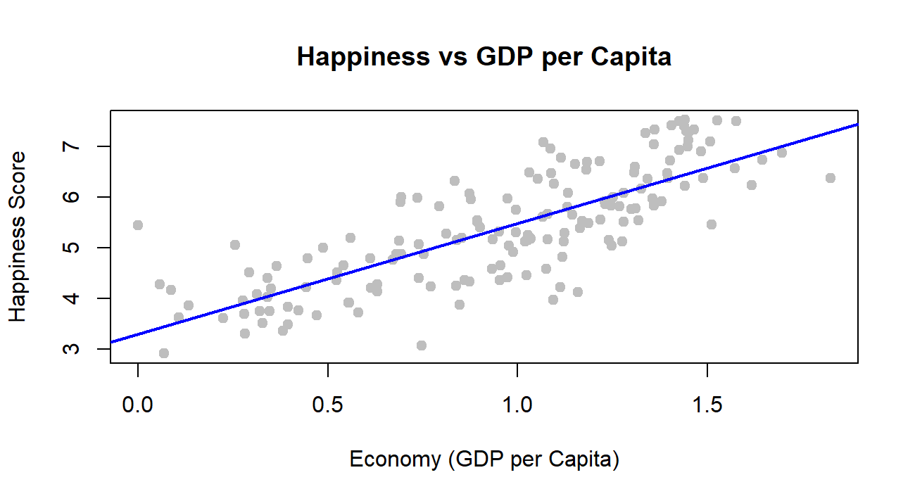

To explore the relationship between Happiness Score and Economy (GDP per Capita), a scatterplot was created. This plot shows how the two variables move together across countries. A linear trendline was added to make the pattern clearer. The scatterplot is suitable for this RQ because it directly shows the possible correlation between the variables.

3.2. Additional information relating to understanding the data (optional)

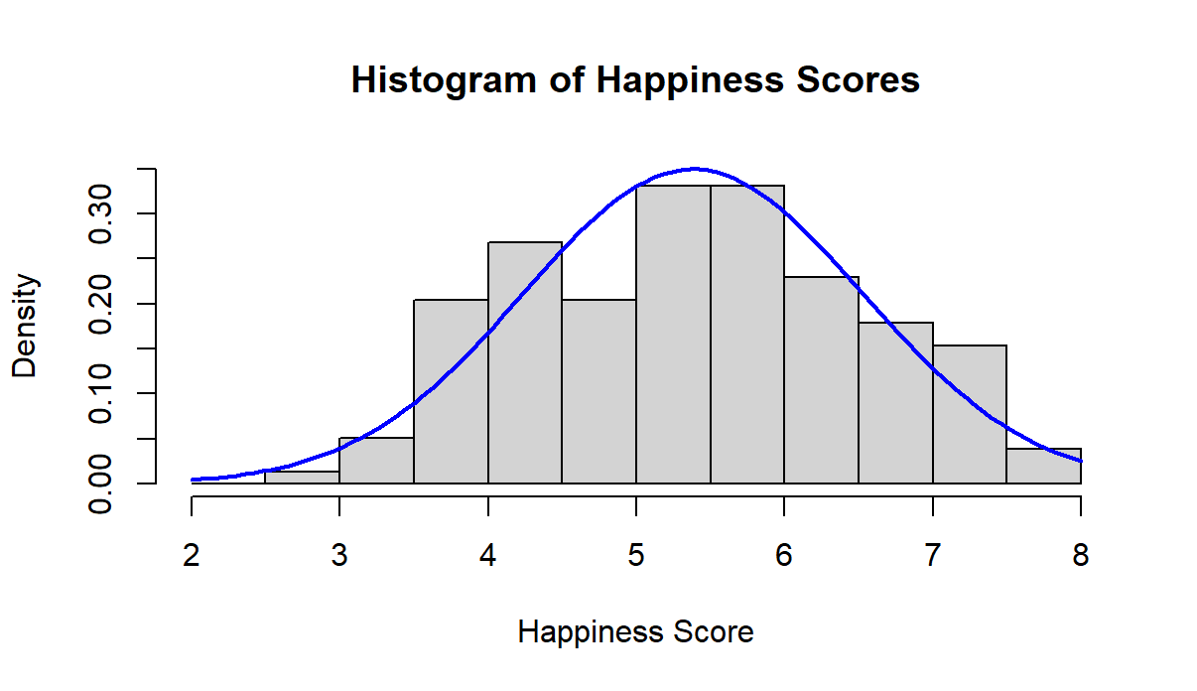

A histogram of the Happiness Score was produced to check whether its distribution is roughly normal. The values form a bell-shaped pattern, which supports using the Pearson correlation test. This graph also helps us see how most countries fall around the middle of the happiness scale, with fewer very low or very high scores.

3.3. Useful information for the data understanding

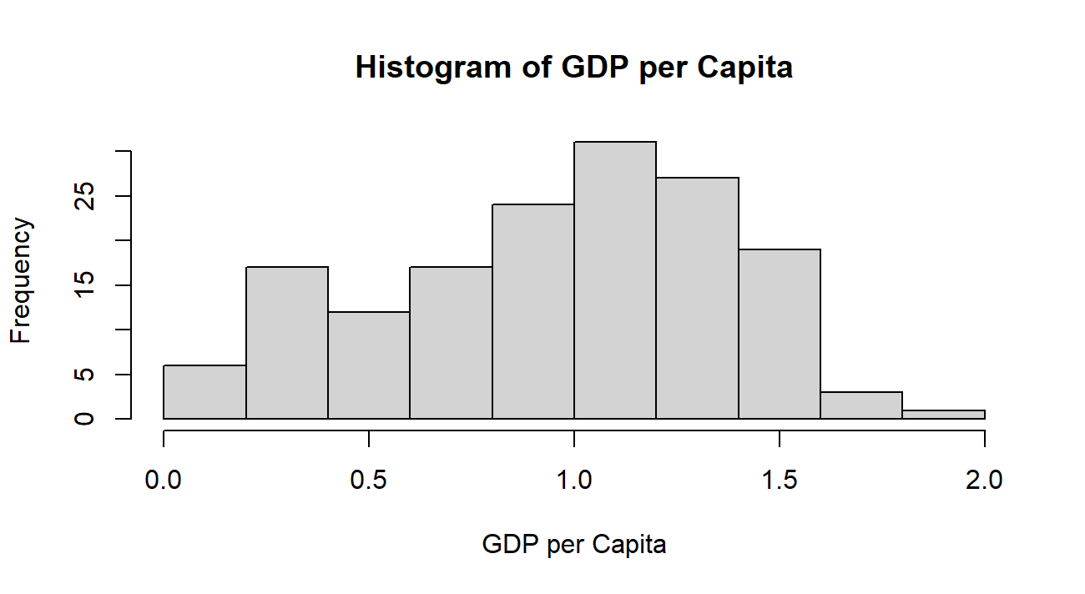

A histogram of GDP per Capita was also created to understand how the economic values are distributed. The GDP scores vary across countries but do not show extreme outliers. This helps confirm that the data is appropriate for correlation analysis, and it adds context to the upward trend observed in the scatterplot.

4. Analysis

4.1. Statistical test used to test the hypotheses and output

The histogram of Happiness Score showed an approximately normal distribution, the Pearson correlation test was used to examine the relationship between the two variables. Pearson correlation measures whether two continuous variables change together in a linear way. The test output included the correlation coefficient (r = 0.79) and a p-value, which helps determine whether the relationship observed in the scatterplot is statistically meaningful.

4.2. The null hypothesis is rejected /not rejected (select one) based on the p-value

The Pearson correlation result showed a strong positive relationship between Happiness Score and GDP per Capita, with r = 0.79. The p-value was extremely small (p < 2.2e-16), which is far below the 0.05 threshold. Because of this, the null hypothesis stating there is no relationship is rejected. This means the correlation is statistically significant and unlikely to be due to chance. The results suggest that wealthier countries tend to have higher levels of happiness, although the scatterplot shows variation, indicating that economic factors are not the only contributors to happiness.

5. Evaluation – group’s experience at 7COM1079

5.1. What went well
5.2. Points for improvement
5.3. Group’s time management
5.4. Project’s overall judgement
5.5. Comment on GitHub log output

6. Conclusions

6.1. Results explained.
6.2. Interpretation of the results
6.3. Reasons and/or implications for future work, limitations
- Reference list
Harvard (author, date) format.
Helliwell, J.F., Layard, R. & Sachs, J. (2016). World Happiness Report 2016. New York: Sustainable Development Solutions Network. Available at: https://worldhappiness.report/ed/2016/ (Accessed 24 October 2025).
Becchetti, L., Corrado, L. & Sama, P. (2016). Inside the Life-Satisfaction Blackbox. World Happiness Report 2016, Chapter 4, pp. 89–120. Sustainable Development Solutions Network. Available at: https://worldhappiness.report/ed/2016/ (Accessed 24 October 2025).
Helliwell, J.F. (2016). The Distribution of World Happiness. World Happiness Report 2016, Chapter 2, pp. 23–54. Sustainable Development Solutions Network. Available at: https://worldhappiness.report/ed/2016/ (Accessed 24 October 2025).
Lee, Y.Y. (2023). The Happiness–Economic Well-Being Nexus: New Insights. SAGE Open, 13(2), pp. 1–12. Available at: https://journals.sagepub.com/doi/10.1177/21582440231199659 (Accessed 24 October 2025).

- Appendices
- R code used for analysis and visualisation.
- GitHub log output.

The list below outlines the chapter/subchapter numbers, names, word count limits, and explanations of what to write in each section.

1. Introduction

  - Problem statement and research motivation (100 words)
- What is the problem in the area we want to learn more about (motivation for study).
- Use at least one citation from related literature for top marks.
  - The data set (75 words)
  - Research question (50 words). State your RQ (50 words)
  - Null hypothesis and alternative hypothesis (H0/H1) (100 words)

- Background research
  - Research papers (at least 3 relevant to your topic / DS) (200 words)
- Was the data set used for some research papers? Summarise and reference at least 3 relevant research papers to your topic / DS. See https://herts.instructure.com/courses/61421/modules for writing.

  - Why RQ is of interest (research gap and future directions according to the literature) (100 words)

- Visualisation
  - Appropriate graphs for the RQ output of an R script (NOT a screenshot) (50 words)
- Explain the choice of the plot.
- Include your main plot relevant to the RQ type.
- Include histogram or contingency table (think what is suitable) in addition to the main plot.
- Anything on the plot from R is not counted towards word count limit (e.g. legend, axes titles, name).
- Make sure that the plot is from output of an R script (NOT a screenshot).
- Make sure that the plot has a caption or title, X and Y-axis labels with units where appropriate, and legend.
- Make sure the title or caption and axis labels are informative and written in English.

  - Additional information relating to understanding the data (optional) (50 words)
- Per plot: explain the purpose and insights.

  - Useful information for the data understanding (50 words)
- Summarise key observations from the plot.

- Analysis
  - Statistical test used to test the hypotheses and output (75 words)
- Explain the choice of the statistical test.
- Make sure the test is appropriate for the RQ and data.

  - The null hypothesis is rejected /not rejected based on the p-value (100 words) (interpret the results)

- Evaluation – group’s experience at 7COM1079
  - What went well (75 words)
  - Points for improvement (75 words)
  - Group’s time management (50 words)
  - Project’s overall judgement (50 words)
  - Note any changes to group since original allocation if applicable. Add new or amended GitHub Ids for new members (75 words, write only if applies to your group arrangements)
  - Comment on the GitHub log output (50 words)
Please comment on the GitHub log output, and refer to it as being placed into Appendix B.
From your Git log, select three most significant commits during this project and include the following for each:
- Commit Message: [Insert Commit Message] Brief explanation of the broader impact of the change
- Commit Message: [Insert Commit Message] Brief explanation of the broader impact of the change
- Commit Message: [Insert Commit Message] Brief explanation of the broader impact of the change

- Conclusions
  - Results explained (75 words)
  - Interpretation of the results (75 words)
- Interpretation of what the results mean in terms of your RQ and the effect this may have on your population and the wider context of your topic.
  - Reasons and/or implications for future work, limitations of your study (50 words)

- Reference list (not included in the word count)
Harvard (author, date) format.

- Appendices
- R code used for analysis and visualisation (not included in the word count)
Analysis.R code with the appropriate statistics to test the hypotheses.
- No word count, but ensure the code is without redundant lines, well-commented and produces the correct output.
- Make sure it runs (look in Rscript.log for output from a statistical test)
- It should compute appropriate statistics to test the hypotheses
- GitHub log output.

